CHAPTER-1
INTRODUCTION

INTRODUCTION
  - Introduction
In the present digital era, technology has become an integral part of the education system, transforming traditional methods of teaching, learning, and evaluation into more efficient and interactive processes. One of the significant areas where this transformation is clearly visible is in the way quizzes and assessments are conducted. Conventional methods of conducting quizzes using pen and paper are gradually being replaced by online platforms that offer better accessibility, faster evaluation, and enhanced user experience.
The Smart Quiz Platform is a web-based application developed using the MERN stack (MongoDB, Express.js, React.js, and Node.js) with the aim of providing a modern solution for quiz management and assessment. The system is designed to create an interactive environment where teachers and students can engage effectively. Teachers are provided with tools to create, manage, and analyze quizzes, while students can attempt quizzes, receive instant feedback, and monitor their academic progress.
Traditional quiz systems have several limitations, including time-consuming manual evaluation, delayed results, and lack of detailed performance analysis. These limitations reduce the effectiveness of assessments and make it difficult for both students and teachers to identify strengths and weaknesses. In addition, maintaining records manually can lead to errors, data loss, and inefficiency in managing large volumes of student data.
The Smart Quiz Platform addresses these challenges by automating the entire quiz process. It allows teachers to create quizzes with multiple-choice questions, set time limits, and define scoring criteria. Students can attempt these quizzes in a structured and time-bound manner, and their responses are evaluated instantly by the system. This immediate feedback helps students understand their mistakes and improve their performance.
Another important feature of the platform is performance tracking and analysis. The system provides detailed insights into student performance through dashboards and graphical representations such as charts and progress indicators. These analytics help students track their progress over time and enable teachers to monitor the overall performance of the class. The inclusion of a leaderboard further enhances engagement by encouraging healthy competition among students.
The platform also ensures secure access through user authentication and role-based functionality. Depending on their role, users are provided with appropriate access and features. The system is designed to be responsive, ensuring that it can be accessed from various devices such as desktops, laptops, tablets, and smartphones, making it convenient for users to access the platform anytime and anywhere.
From a technical perspective, the use of the MERN stack enables the development of a scalable and efficient application. React.js is used for building a dynamic and responsive user interface, Node.js and Express.js handle server-side operations and API management, and MongoDB provides a flexible and scalable database solution. This combination of technologies ensures high performance, maintainability, and future scalability of the application.
Overall, the Smart Quiz Platform represents a significant step towards modernizing the assessment process in educational institutions. It not only simplifies quiz management but also enhances the learning experience by providing instant feedback, detailed performance analysis, and an interactive environment. The system demonstrates how modern web technologies can be effectively utilized to develop innovative solutions that address real-world problems in education.

  - Problem Statement
In many educational institutions, quizzes and assessments are still conducted using traditional or partially digital methods, which lead to several inefficiencies and limitations. The process of preparing question papers, distributing them, and manually evaluating answer sheets is time-consuming and requires significant effort from teachers. This often results in delays in announcing results, reducing the effectiveness of assessments.
Additionally, traditional systems do not provide immediate feedback to students, making it difficult for them to identify their mistakes and improve their understanding. There is also a lack of proper performance tracking, as students cannot easily monitor their progress over time, and teachers find it challenging to analyze class performance or identify weak areas.
Another major issue is the absence of a centralized system for managing quizzes and student data. Maintaining records manually increases the chances of errors, data loss, and inconsistency. Furthermore, traditional methods do not support interactive features such as leaderboards, notifications, or graphical analysis, which are important for improving student engagement and motivation.
Therefore, there is a need for a robust and automated system that can streamline quiz management, provide instant evaluation, ensure secure data handling, and offer detailed performance insights for both students and teachers.

  - Objectives of the Project
The main objective of the Smart Quiz Platform is to develop an efficient and user-friendly web-based system for conducting and managing online quizzes. The project aims to simplify the process of quiz creation, participation, and evaluation while enhancing the overall learning experience.
The specific objectives of the project are:
- To design and develop a role-based application for students and teachers
- To enable teachers to create, edit, and manage quizzes easily
- To allow students to attempt quizzes in a timed and interactive environment
- To provide instant evaluation and feedback after quiz submission
- To implement performance tracking through dashboards and charts
- To develop a leaderboard system to encourage healthy competition among students
- To ensure secure user authentication and data management
- To create a responsive and user-friendly interface accessible on multiple devices
- To build a scalable system that can be extended with advanced features in the future
These objectives focus on improving efficiency, accuracy, and engagement in the quiz and assessment process.

1.4 Scope of the Project
The Smart Quiz Platform is designed to provide a complete solution for conducting and managing online quizzes in educational environments such as schools, colleges, and training institutes. The scope of the project includes the development of a web-based application that supports both students and teachers through role-based access and functionality.
For students, the platform allows registration, login, attempting quizzes, viewing results, tracking performance, and accessing leaderboards. For teachers, it provides features to create, edit, delete, and manage quizzes, as well as monitor student performance and analyze results through dashboards.
The system covers the entire quiz lifecycle, including quiz creation, participation, automatic evaluation, and result analysis. It also includes features such as notifications, performance analytics, and responsive design to ensure accessibility across different devices like desktops, laptops, tablets, and smartphones.
Although the current implementation focuses on core functionalities, the platform is scalable and can be extended in the future to include advanced features such as mobile application support, real-time updates, and integration with other educational systems.

CHAPTER-2
SYSTEM OVERVIEW

SYSTEM OVERVIEW
2.1 Existing System
In the existing system, quizzes and assessments are primarily conducted using traditional methods such as pen-and-paper tests. Teachers prepare question papers manually, distribute them to students, and later collect the answer sheets for evaluation. The entire process is time-consuming and requires significant manual effort from educators.
In some cases, basic digital tools like word processors or simple online forms are used to create quizzes. However, these tools still lack advanced features such as automated evaluation, detailed performance analysis, and centralized data management. Results are often calculated manually or semi-automatically, which can lead to errors and inconsistencies.
Moreover, students do not receive immediate feedback on their performance, making it difficult for them to understand their mistakes and improve. There is also no proper system to store and track past quiz data, which limits the ability to monitor progress over time.
Overall, the existing system is inefficient, less interactive, and does not meet the requirements of modern digital learning environments.

2.2 Limitations of Existing System
The existing quiz and assessment system, which is mostly manual or partially digital, has several limitations that affect efficiency, accuracy, and user experience.
- Time-consuming process: Preparing question papers, conducting exams, and evaluating answer sheets manually requires a significant amount of time and effort from teachers.
- Delayed results: Students do not receive immediate feedback, which slows down the learning process and reduces the effectiveness of assessments.
- Error-prone evaluation: Manual checking can lead to calculation mistakes and inconsistencies in grading.
- Lack of performance analysis: There are no proper tools to track student progress, analyze performance trends, or identify weak areas.
- No centralized data management: Maintaining records manually can result in data loss, duplication, or difficulty in retrieving past information.
- Limited accessibility: Traditional quizzes cannot be accessed remotely and are restricted to physical classrooms.
- Low student engagement: The absence of interactive features such as leaderboards, instant feedback, and visual analytics reduces student interest and motivation.
- Difficulty in quiz management: Teachers cannot easily reuse, edit, or organize quizzes once they are conducted.
These limitations highlight the need for a modern, automated system to improve the efficiency and effectiveness of quiz management and evaluation.

2.3 Proposed System
The proposed system, the Smart Quiz Platform, is a web-based application developed using the MERN stack (MongoDB, Express.js, React.js, and Node.js) to overcome the limitations of the existing quiz system. It provides a fully automated and interactive environment for conducting and managing quizzes efficiently.
In this system, teachers can easily create, edit, delete, and manage quizzes through a user-friendly interface. They can define quiz parameters such as time limits, number of questions, and scoring criteria. Once created, quizzes can be published instantly, allowing students to access and attempt them at any time.
Students can log in to the platform, browse available quizzes, and attempt them in a structured and time-bound manner. The system automatically evaluates their responses and provides instant feedback, including scores and correct answers. This helps students quickly identify their mistakes and improve their understanding.
The platform also includes advanced features such as performance dashboards, graphical analysis, and leaderboards. These features enable both students and teachers to track performance, analyze progress, and encourage healthy competition. Notifications keep users informed about new quizzes and updates.
Overall, the proposed system provides a centralized, efficient, and scalable solution for quiz management, improving both teaching and learning experiences while reducing manual effort and errors.

2.4 Software Requirements
The Smart Quiz Platform requires a set of software tools and technologies for its development, deployment, and execution. These requirements ensure the smooth functioning of both the frontend and backend of the application.
- Operating System: Windows, Linux, or macOS
- Frontend Technologies:
  - HTML5 for structuring web pages
  - CSS3 for styling and responsive design
  - JavaScript (ES6) for dynamic functionality
  - React.js for building the user interface
- Backend Technologies:
  - Node.js for server-side runtime environment
  - Express.js for handling API requests and routing
- Database:
  - MongoDB for storing user data, quizzes, and results
- Libraries and Tools:
  - Chart.js for data visualization
  - Axios for API communication
  - JSON Web Tokens (JWT) for authentication
  - Font Awesome for icons
- Development Tools:
  - Visual Studio Code (VS Code) as the code editor
  - Git for version control
- Web Browser:
  - Google Chrome, Mozilla Firefox, Microsoft Edge, or Safari (latest versions)
These software requirements provide the necessary environment for developing and running the Smart Quiz Platform efficiently.

2.5 Hardware Requirements
The Smart Quiz Platform requires minimal hardware resources, making it accessible for both development and usage across a wide range of devices.
- Server Requirements (for deployment):
  - Processor: Minimum Intel i3 or equivalent
  - RAM: 4 GB or higher
  - Storage: At least 20 GB free disk space
  - Network: Stable internet connection
- Client Requirements (for users):
  - Device: Desktop, laptop, tablet, or smartphone
  - Processor: Basic processor capable of running a web browser
  - RAM: Minimum 2 GB
  - Storage: Not mandatory (web-based application)
  - Network: Internet connection for accessing the platform
- Peripherals (optional):
  - Keyboard and mouse (for desktops/laptops)
  - Touchscreen support (for mobile devices)
These hardware requirements ensure that the system can run efficiently on standard devices without requiring high-end infrastructure.

CHAPTER-3
TECHNOLOGIES USED

TECHNOLOGIES USED
3.1 Overview of Technology Stack
3.1.1 Node.js
Node.js is a server-side runtime environment that allows JavaScript to be executed outside the browser. It is built on Chrome’s V8 JavaScript engine and is known for its fast performance and non-blocking, event-driven architecture.
In this project, Node.js is used to handle backend operations such as processing user requests, managing quiz data, and communicating with the database. It ensures efficient handling of multiple users simultaneously and enables the development of a scalable server-side application.
3.1.2 Express.js
Express.js is a lightweight web application framework for Node.js that simplifies the development of backend applications. It provides features such as routing, middleware support, and easy handling of HTTP requests and responses.
In the Smart Quiz Platform, Express.js is used to create RESTful APIs that connect the frontend with the backend. It handles operations such as user authentication, quiz management, and data processing, making the backend structured and efficient.
3.1.3 React.js
React.js is a popular JavaScript library used for building interactive and dynamic user interfaces. It is based on a component-based architecture, which allows developers to create reusable UI components.
In this project, React.js is used to design the frontend of the application. It helps in creating responsive dashboards, quiz interfaces, and user-friendly pages for both students and teachers. React ensures smooth navigation and improves overall user experience.

3.1.4 MongoDB (Database)
MongoDB is a NoSQL database used to store data in a flexible, JSON-like format called documents. It is highly scalable and suitable for handling large amounts of data.
In the Smart Quiz Platform, MongoDB is used to store user information, quizzes, student attempts, and notifications. It allows efficient data retrieval and management, ensuring that the application performs well even with increasing data.

3.1.5 Additional Technologies
- HTML5: Used for structuring web pages
- CSS3: Used for styling and responsive design
- JavaScript (ES6): Used for implementing dynamic functionality
- Chart.js: Used for data visualization and performance charts
- Axios: Used for API communication between frontend and backend
- JWT (JSON Web Tokens): Used for secure authentication

CHAPTER-4
DATABASE DESIGN

DATABASE DESIGN
4.1 Database Tables (Collections)
In the Smart Quiz Platform, MongoDB is used as the database. Instead of tables, MongoDB uses collections, which store data in document format. The main collections used in the project are:
- Users Collection
- Quizzes Collection
- Attempts Collection
- Notifications Collection

4.2 Table Structure

4.2.1 Users Collection :
Field Name | Data Type | Description
_id | ObjectId | Unique identifier for each user
name | String | Name of the user
email | String | Email address (unique)
password | String | Encrypted password
role | String | User role (student/teacher)
createdAt | Date | Account creation date

Table 1: User Collection Relational Database Table

4.2.2 Quizzes Collection :
Field Name | Data Type | Description
_id | ObjectId | Unique quiz ID
title | String | Quiz title
category | String | Subject/category
difficulty | String | Difficulty level
questions | Array | List of questions
timeLimit | Number | Time duration in minutes
createdBy | ObjectId | Teacher ID
createdAt | Date | Quiz creation date

Table 2: Quizzes Collection Relational Database Table

4.2.3 Attempts Collection :
Field Name | Data Type | Description
_id | ObjectId | Unique attempt ID
userId | ObjectId | Student ID
quizId | ObjectId | Quiz ID
answers | Array | Student answers
score | Number | Marks obtained
total | Number | Total marks
date | Date | Attempt date

Table 3: Attempts Collection Relational Database Table

4.2.4 Notifications Collection :
Field Name | Data Type | Description
_id | ObjectId | Unique notification ID
userId | ObjectId | User ID
message | String | Notification content
read | Boolean | Read/unread status
createdAt | Date | Notification time

Table 4: Notifications Collection Relational Database Table

4.3 Keys and Constraints
To maintain data integrity, the following keys and constraints are used:
- Primary Key:
Each collection uses _id as the primary key, which uniquely identifies each document.
- Unique Fields:
Email field in Users collection is unique to prevent duplicate accounts.
- NOT NULL Fields:
Fields like name, email, password, and role are mandatory.
- Foreign Key (Reference):
Fields like userId and quizId are used to link collections.

4.4 Table Relationships
The collections are related to each other using reference IDs:
- Users ↔ Attempts
(One user can have many attempts)
- Quizzes ↔ Attempts
(One quiz can be attempted by many students)
- Users ↔ Quizzes
(One teacher can create multiple quizzes)
- Users ↔ Notifications
(Each user receives multiple notifications)
These relationships help in efficient data retrieval and management.

CHAPTER-5
SYSTEM MODULES

SYSTEM MODULES
5.1 System Modules
The Smart Quiz Platform is divided into several modules to ensure proper organization, efficient functionality, and ease of use. Each module performs a specific task and contributes to the overall working of the system.

5.1.1 Authentication Module
This module handles user registration and login functionality. It allows users to sign up by providing necessary details such as name, email, password, and role (student or teacher). The system verifies user credentials during login and provides secure access using authentication mechanisms. Based on the user role, the system redirects users to their respective dashboards.
5.1.2 Student Module
The Student Module provides all functionalities required for students to interact with the system. Students can view available quizzes, attempt quizzes within a given time limit, and receive instant results after submission. They can also track their performance through dashboards, view past attempts, and check their ranking in the leaderboard. This module enhances learning by providing feedback and performance insights.
5.1.3 Teacher Module
The Teacher Module allows teachers to create, manage, and monitor quizzes. Teachers can add new quizzes, edit existing ones, delete unwanted quizzes, and set parameters such as time limits and difficulty levels. They can also view student performance, analyze results, and track class progress. This module simplifies quiz management and evaluation.
5.1.4 Quiz Management Module
This module handles the creation, storage, and retrieval of quizzes. It ensures that quizzes are properly structured with questions, options, and correct answers. It also manages quiz availability and ensures that students can access quizzes easily. The module plays a key role in organizing quiz data efficiently.
5.1.5 Notification Module
The Notification Module is responsible for informing users about important updates. Students receive notifications when new quizzes are added or when they complete a quiz. These notifications improve user engagement and ensure that users stay updated with the latest activities on the platform.
5.1.6 Reporting and Analytics Module
This module provides detailed insights into student performance using charts and graphical representations. It includes features such as score analysis, accuracy tracking, and progress monitoring. Teachers can analyze class performance, while students can track their individual growth. This module helps in making data-driven decisions and improving learning outcomes.
5.1.7Leaderboard Module
The Leaderboard Module displays the ranking of students based on their quiz performance. It shows scores in descending order, allowing students to compare their performance with others. The module uses data from quiz attempts to calculate rankings. It motivates students to improve their scores and encourages healthy competition. Teachers can also use it to monitor overall student performance.

CHAPTER - 6
SYSTEM IMPLEMENTATION

SYSTEM IMPLEMENTATION

6.1 Implementation
The implementation of the Smart Quiz Platform involves the development of both frontend and backend components using the MERN stack. The system is designed in a modular manner, ensuring scalability, maintainability, and efficient performance. The implementation process includes setting up the development environment, designing the user interface, developing server-side logic, and integrating the database.
6.1.1 Frontend Implementation
The frontend of the application is developed using React.js, which provides a dynamic and responsive user interface. The application is divided into reusable components such as login, dashboard, quiz interface, and leaderboard. React Router is used for navigation between different pages.
HTML5 and CSS3 are used for structuring and styling the application, ensuring a clean and responsive design across different devices. JavaScript (ES6) is used to handle user interactions, form validations, and dynamic content updates. Axios is used to send HTTP requests to the backend APIs.

6.1.2 Backend Implementation
The backend is developed using Node.js and Express.js. Express.js is used to create RESTful APIs that handle various operations such as user authentication, quiz management, and result processing.
The server handles incoming requests from the frontend, processes the data, and sends appropriate responses. Middleware functions are used for tasks such as authentication, error handling, and request validation. JSON Web Tokens (JWT) are used to ensure secure user authentication and authorization.

6.1.3 Database Implementation
MongoDB is used as the database to store application data. Mongoose is used as an Object Data Modeling (ODM) library to define schemas and interact with the database.
Collections such as Users, Quizzes, Attempts, and Notifications are created to store relevant data. CRUD (Create, Read, Update, Delete) operations are performed to manage data efficiently. The database ensures data persistence and quick retrieval.

6.1.4 Integration of Frontend and Backend
The frontend and backend are integrated using REST APIs. Axios is used on the frontend to send requests to the backend server. The backend processes these requests and interacts with the MongoDB database to fetch or store data.
Data is exchanged in JSON format, ensuring smooth communication between client and server. Proper error handling and validation are implemented to maintain data integrity and application stability.

6.1.5 Testing and Debugging
The system is tested at different stages to ensure proper functionality. Unit testing is performed on individual components, while integration testing ensures that different modules work together correctly.
Debugging tools such as browser developer tools and console logs are used to identify and fix errors. The application is tested across different browsers and devices to ensure compatibility and responsiveness.

6.1.6 Deployment
The application can be deployed on cloud platforms such as Heroku, Vercel, or Netlify. The backend server is hosted on a server environment, while the frontend is deployed as a static web application.
Environment variables are used to manage sensitive data such as database connection strings and secret keys. Once deployed, the application can be accessed by users through a web browser.

CHAPTER - 7
OUTPUT SCREENS

OUTPUT SCREENS

Login Screen:
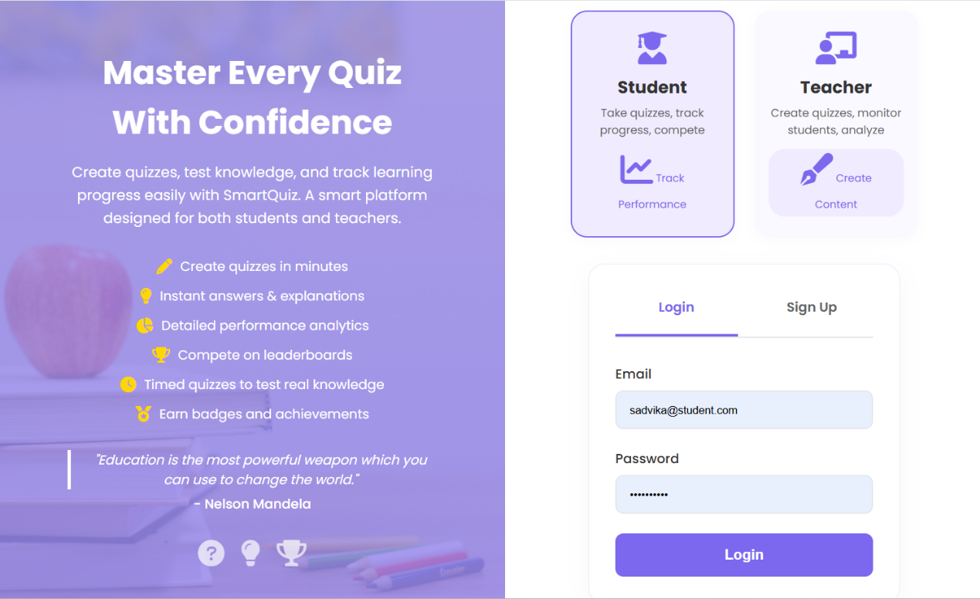

Figure 1: Login Screen of Smart Quiz Platform
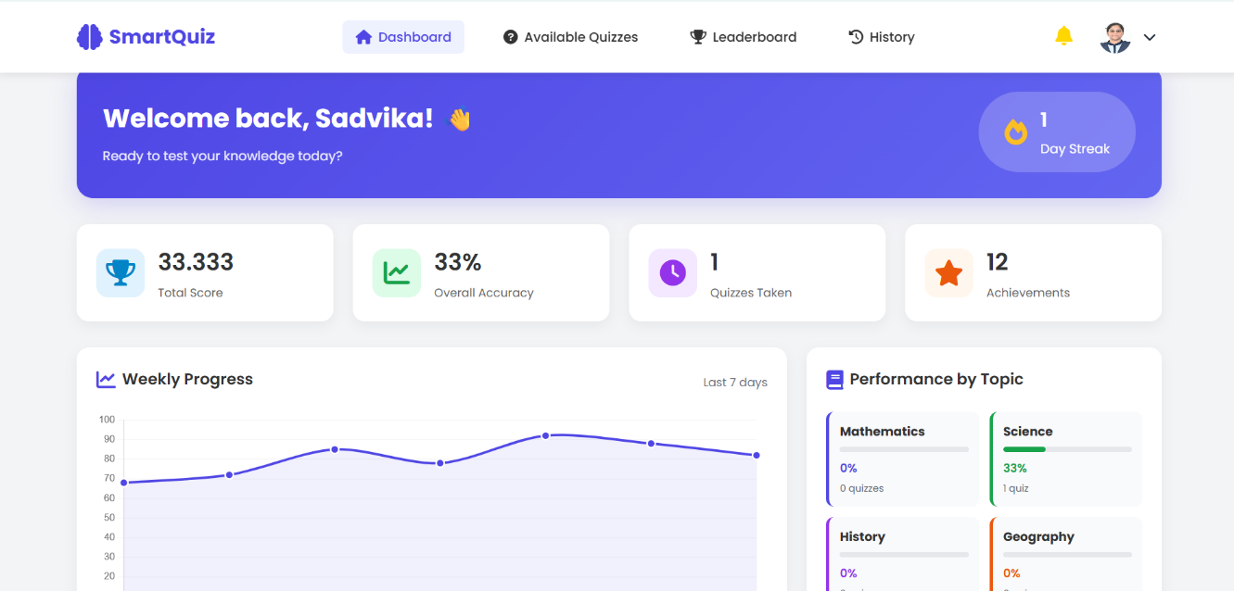
Student Dashboard:

Figure 2: Student Dashboard of Smart Quiz Platform
Teacher Dashboard:
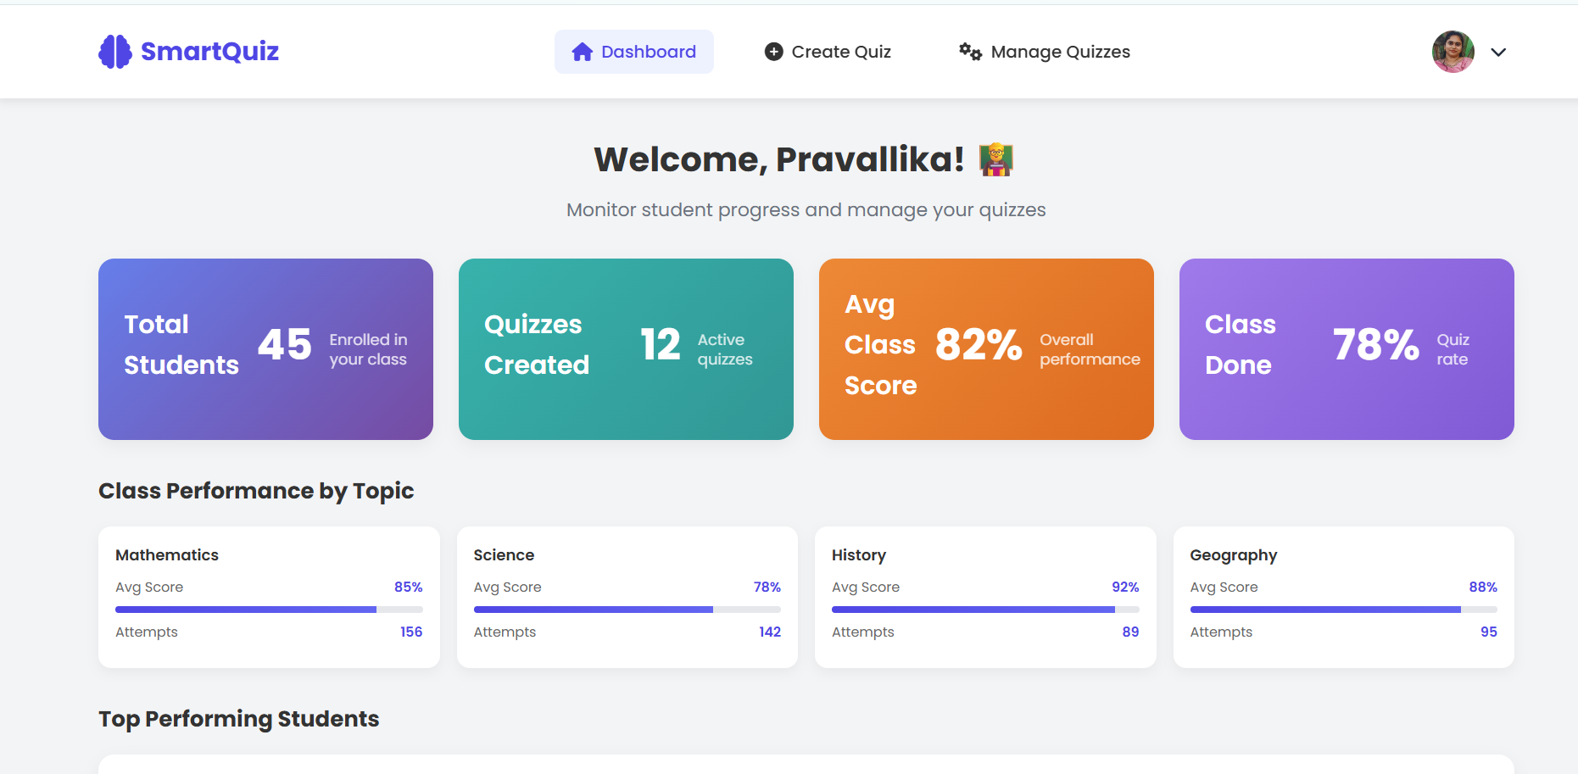
Figure 3: Teacher Dashboard of Smart Quiz Platform

Ouiz Creation:
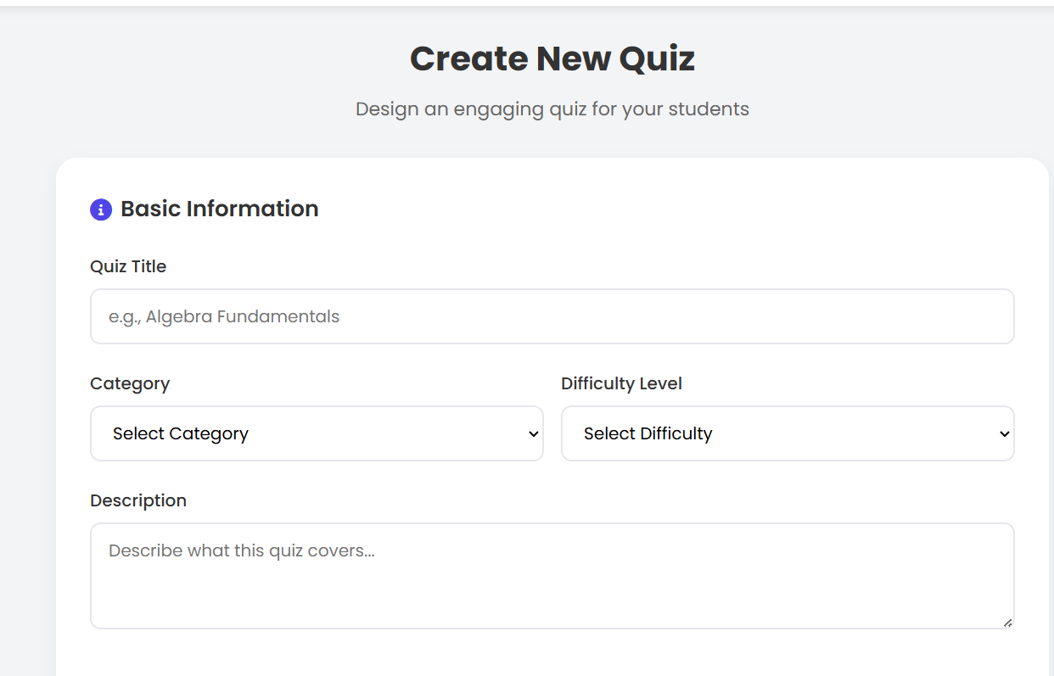

Figure 4: Quiz Creation of Smart Quiz Platform
Available Quizzes:
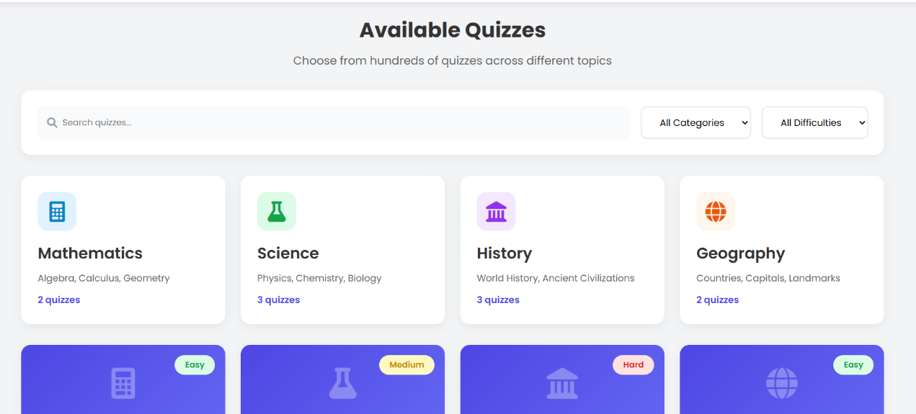

Figure 5: Available Quizzes of Smart Quiz Platform
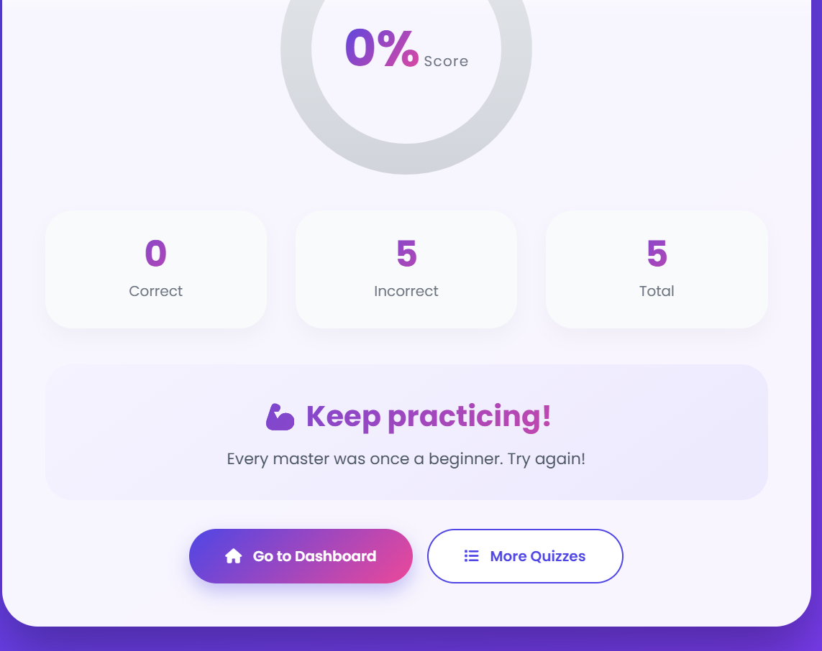
Result Display:

Figure 6: Result Display of Smart Quiz Platform

Leaderboard Module:
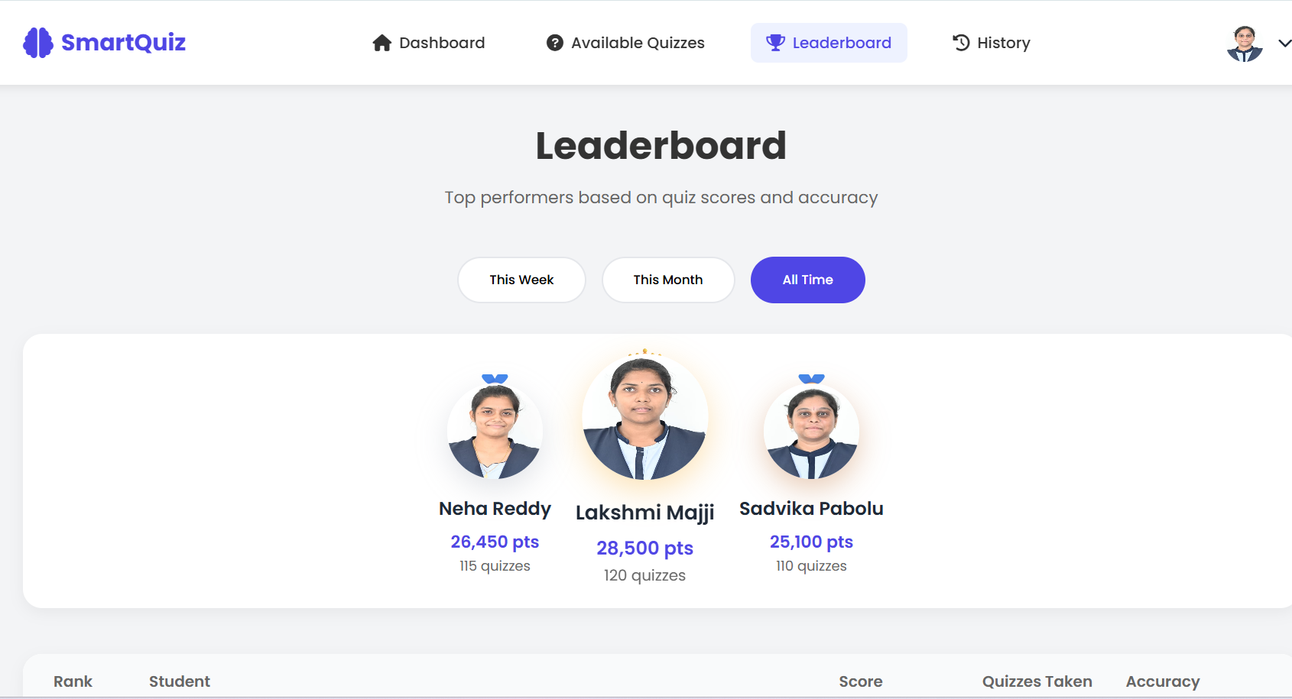
Figure 7: Leaderboard of Smart Quiz Platform

8. CONCLUSION
The Smart Quiz Platform developed using the MERN stack (MongoDB, Express.js, React.js, and Node.js) provides a comprehensive and efficient solution for conducting online quizzes and managing student performance. The system is designed to be user-friendly, scalable, and interactive, meeting the needs of both students and teachers. It simplifies the process of quiz creation, participation, and evaluation through a well-structured and integrated approach.Throughout the development of this project, various modules such as authentication, quiz management, student dashboard, teacher dashboard, leaderboard, and notification system have been successfully implemented. These modules work together to provide a seamless experience for users. Students can easily access quizzes, attempt them within a specified time, and receive instant results. Teachers can create, modify, and manage quizzes while also monitoring student progress and performance effectively.
The use of modern technologies like React.js for frontend development ensures a responsive and dynamic user interface, while Node.js and Express.js handle backend operations efficiently. MongoDB, as a NoSQL database, provides flexibility in storing and managing large amounts of data. The integration of these technologies results in a robust and high-performing application. One of the key strengths of this system is its ability to provide real-time feedback and performance analysis. Features such as score tracking and leaderboard rankings encourage students to improve their performance and stay engaged. The platform also promotes healthy competition among students, which enhances the overall learning experience.
In addition, the system ensures data security through proper authentication and authorization mechanisms. The modular design of the application makes it easy to maintain and extend in the future. New features can be added without affecting the existing functionality, making the system highly adaptable.
Overall, the Smart Quiz Platform achieves its goal of providing a reliable, secure, and efficient environment for online assessment. It not only improves the learning process for students but also reduces the workload for teachers. This project demonstrates the practical implementation of web development technologies in solving real-world educational challenges and has the potential to be further enhanced with advanced features in the future.
9. FUTURE ENHANCEMENTS
The Smart Quiz Platform can be further improved by adding advanced features to enhance functionality, user experience, and system performance. Some of the possible future enhancements are:
- AI-Based Performance Analysis:
Integrate machine learning algorithms to analyze student performance and provide personalized recommendations for improvement.
- Adaptive Quiz System:
Implement adaptive quizzes where the difficulty level changes automatically based on the student’s performance.
- Mobile Application:
Develop a mobile app using React Native to allow users to access the platform on smartphones and tablets.
- Real-Time Quiz Feature:
Introduce live quizzes where multiple students can participate simultaneously with real-time score updates.
- Gamification:
Add badges, rewards, and achievements to increase student engagement and motivation.
- Advanced Analytics Dashboard:
Provide detailed reports and visualizations for teachers to better understand student progress and learning patterns.
- Multilingual Support:
Enable multiple language options to make the platform accessible to a wider audience.
- Integration with Learning Management Systems (LMS):
Connect the platform with existing LMS platforms like Moodle or Google Classroom.
- Improved Security Features:
Implement advanced security measures such as two-factor authentication and data encryption.
- Offline Mode:
Allow users to attempt quizzes offline and sync data once the internet connection is restored.
These enhancements can make the system more powerful, user-friendly, and suitable for real-world educational environments.

10. REFERENCES
The following references were used in the development of the Smart Quiz Platform:
- MongoDB Documentation – MongoDB Official Website
https://www.mongodb.com/docs/
- Node.js Documentation – Node.js Official Website
https://nodejs.org/en/docs/
- Express.js Guide – Express Official Website
https://expressjs.com/
- React.js Documentation – React Official Website
https://react.dev/
- MDN Web Docs – Mozilla Developer Network
https://developer.mozilla.org/
- W3Schools Online Web Tutorials
https://www.w3schools.com/
- JSON Web Token (JWT) Introduction – jwt.io
https://jwt.io/introduction/
- Axios Documentation – Axios GitHub Repository
https://axios-http.com/
- GitHub – Version Control and Code Repository
https://github.com/
- Stack Overflow – Developer Community
https://stackoverflow.com/

APPENDIX
A.1 Sample Code
1. User Schema (MongoDB - Mongoose)
const mongoose = require('mongoose');
const userSchema = new mongoose.Schema({
name: String,
email: { type: String, unique: true },
password: String,
role: String,
createdAt: { type: Date, default: Date.now }
});
module.exports = mongoose.model('User', userSchema);

2. Express Server Setup
const express = require('express');
const app = express();
app.use(express.json());
app.get('/', (req, res) => {
res.send("Server Running");
});
app.listen(5000, () => {
console.log("Server started on port 5000");
});

3. React Login Component (Basic)
import React, { useState } from 'react';
import axios from 'axios';
function Login() {
const [email, setEmail] = useState('');
const [password, setPassword] = useState('');
const handleLogin = async () => {
const res = await axios.post('/api/login', { email, password });
console.log(res.data);
};
return (
<div>
<input type="email" onChange={(e) => setEmail(e.target.value)} />
<input type="password" onChange={(e) => setPassword(e.target.value)} />
<button onClick={handleLogin}>Login</button>
</div>
);
}
export default Login;

A.2 Sample API Endpoints
The Smart Quiz Platform uses a set of RESTful API endpoints to enable communication between the frontend and backend. The system provides a registration API (/api/register) that allows new users to create an account by submitting their details. For authentication, a login API (/api/login) is used to verify user credentials and grant access to the system.
To manage quizzes, a GET API (/api/quizzes) is used to retrieve all available quizzes, while a POST API (/api/quizzes) allows teachers to create new quizzes by submitting quiz data. Students can attempt quizzes and submit their answers through the attempt API (/api/attempt), which processes responses and calculates scores.
Additionally, the system includes a leaderboard API (/api/leaderboard) that fetches and displays the ranking of students based on their performance. These APIs ensure smooth data flow, efficient communication, and proper functioning of all modules in the application.

A.3 Sample Output (JSON Data)
{
"userId": "U101",
"quizId": "Q201",
"score": 8,
"total": 10,
"date": "2026-03-20"
}

